20 Sept. 2017
Elliot Chandler (Wallace) — Favorite Scene from Unbreakable — 301 words

In the film Unbreakable, my favorite scene was when the protagonist and the protagonist’s wife and child were in their kitchen in a gun standoff. This was my favorite because I really liked how effective it was at conveying the tension of the situation. (This was the most high-tension scene in the film for me.) The way it was filmed was by having a camera in the space left on the long leg of the triangle demarcated by the three characters’ locations. That leg of the triangle served as the “one hundred eighty degree” line beyond which the camera did not pass in the scene, although it moved along it and changed in its direction within that angle. The camera was moved to show the different characters depending on who the focus was on, to help the viewer follow the interactions in the scene. It also moved from nearer one character’s visual perspective to another; I suspect the motivation of this was to allow the viewer to try to understand the scene from the characters’ thought-perspectives as well, to make the viewer feel emotionally invested in each of the characters’ positions in the conflict, and to make the different perspectives relatable. The camera motions weren’t perfectly smooth (they weren’t the often-abused “shaky” camera effect, thankfully), which I interpret as representing the instability of the situation (a “happy” outcome for the situation did not feel particularly likely). There was a background shown in the scene, but the characters were the visual focus for the scene, highlit by lighting, and I think the background was there simply as a product of where the scene had begun, rather than as something to focus on: I did not notice it while watching, although if it had been absent it would have probably been conspicuous thereby.

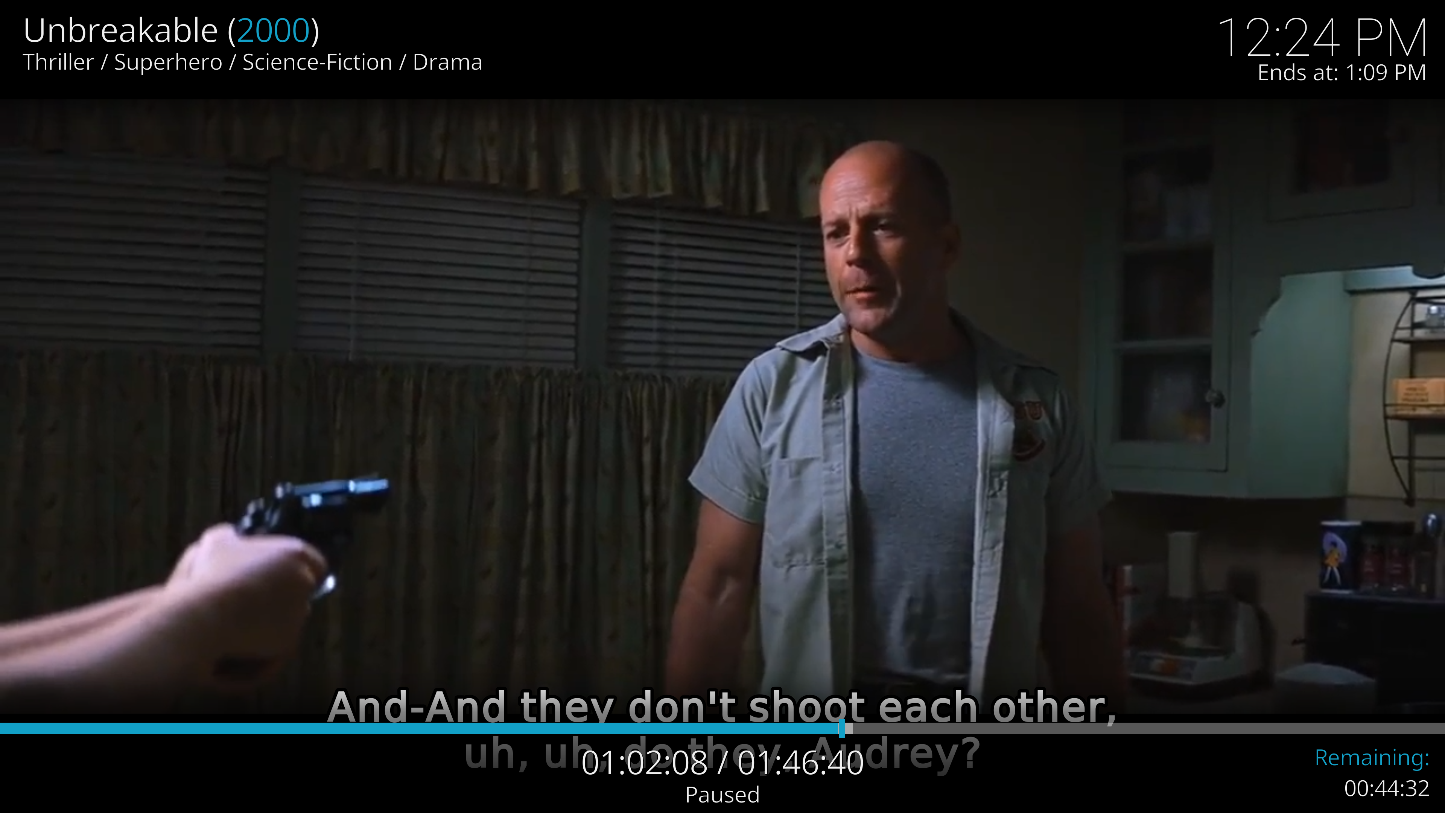
(I used a different copy of the film since the one in Drop Box didn’t have subtitles — I usually find it hard to follow dialogue without subs.)

